September/October 2025 Volume 5
Chestnut Hill Church UCC
Newsletter

Hello Everyone! We have a busy October coming up!!!
WWW has fundraisers scheduled in October to raise funds for the Church Utilities and for our local community. Please check them out and support the fundraisers you are able to attend.
We are holding a Car Show & Trunk or Treat Event at the church.
Saturday, October 18th, Rain date, October 25th. Time - 2:00 to 5:00 pm.
Register at mtrinkle@fabconinc.com
Flyers are attached for our October fundraisers.

TABLE OF CONTENTS
A Letter from Pastor Linda …………………….……………...……pg. 2
Volunteer Opportunities………………………………………......…pg. 3
Outside the Church ………………………………….........................pg. 4-6
Women Working Wonders! ….………………………………….….pg. 4
Special Events……...……………………………………………...…pg. 6
Church Updates …………....……………………………………...... pg. 7-9 Chestnut Hill Grief Support Group ………………………….….…... pg. 8
Financial report……………………………………………………….pg. 9-10

Letter from Pastor Linda

Dear Chestnut Hill Church Family,
The days are getting shorter but for now the birds still come to the feeders, the grass is still green, and the leaves are still on the trees. But I know these things will soon change as the beginning of Fall is just around the corner and the next thing we know, it will be Christmas.
Seasons come and seasons go but I find comfort in the setting of the sun and even the rainbow that appears after a storm to remind us God promised to never again destroy the earth by flooding. His Word gives us assurances. From 2 Corinthians 1:20, we read “For no matter how many promises God has made, they are “Yes” in Christ. And so through him the “Amen” is spoken by us to the glory of God.” (NIV). And from Deuteronomy 7:9: Know therefore that the Lord your God is God; he is the faithful God, keeping his covenant of love to a thousand generations of those who love him and keep his commandments (NIV). And one more - Philippians 4:19: And my God will meet all your needs according to the riches of his glory in Christ Jesus.
I’m reminded of the old Hymn – Standing on the Promises of God, verse 2: Standing on the promises that cannot fail when the howling storms of doubt and fear assail. By the living Word of God I shall prevail, I’m standing on the promises of God.
I can’t speak for anyone else, but I must admit that for a while now, I have been unsettled by the events occurring in our cities, our states, our nation and our world. It even seems to me at times that perhaps even Mother Nature has lost her mind. There are days when I almost want to just close the doors and windows, shut off the computer and the television and pretend that the world outside doesn’t even exist. But I can’t do that; I have responsibilities to take care of my home and my husband, to keep in touch with family members and friends, and to tend my flock. And so, when the doubts and fear seem to be winning, I remind myself that God’s promises cannot fail. As sure as the sun rises tomorrow and night follows day, our God is faithful to save, love and protect now and always.
Resting in my Savior as my All in all, standing on the promises of God.
In His Love which never fails,
Pastor Linda
Volunteer Opportunities

Finance Team

The Finance Team is looking for weekly Sunday Counters and people to join the finance team. The finance team reviews and sets the annual budget and then the budget is presented to Council in November for approval. If interested, please contact Debbie Koder 610-390-9026

Volunteer Opportunities

There are many opportunities within the church share your time and talents to help the church with its mission in this world. We are looking for folks to serve on the Board of Trustees (building and maintenance team). If you are interested in helping, please contact Trustee – Debbie Koder.

Communion Assistants

We are looking for volunteers to help set up, serve, and break down the monthly communion elements on the first Sunday of each month. If you have never done this, someone will gladly show you where everything is and how to set it up.
You only need to arrive at church around 9:15 am, it takes about ½ hour to set up.
If you are interested, please let Marj Trinkle know. A sign-up sheet is available on the Lower Narthex bulletin board with detailed instructions.

Refreshments & Altar Flowers

Anyone who is interested in providing Refreshments or the Altar Flowers for any Sunday, there is a sign-up sheet on the bulletin board on the Lower Narthex. When services are being held in the Fellowship Hall during the summer months, sign-up sheets are on back tables.
Refreshments are served after the Worship Service in the Fellowship Hall downstairs. Coffee, tea and water are provided.
The Altar Flowers, you provide for the Sunday Worship Service and take them home with you. Please indicate if they are in dedication for someone.

Outside the Church

Women Working Wonders!

WWW Meetings is held on the 3rd Thursday of the month at 1 pm, at the church, either in the Sunday School Room or the Fellowship Hall. Everyone is welcome to join us with ideas or help.

Upcoming WWW Events:
10/3/2025: Set up for Raffle at LM Fire Hall
10/4/2025: 3rd Annual Basket Raffle, Lower Milford Fire Hall, 8:00 AM – 3:00 PM Time of Raffle ticket sales 10:00 AM – 1:45 PM
We are holding our 3rd annual Basket Raffle, Saturday, October 4, at the Lower Milford Fire House. 10 am to 2 pm. Last ticket sales at 1:45 pm. Drawing starts at 2 pm. There will also be food and baked goods to be purchased.
Donations of baked goods and Crock Pot soups are greatly appreciated!!! Contact Debbie Weighknecht to inform her of your food contribution.
We also plan on having a raffle special. Bring a donation for Animals In Distress and be entered to win a special basket prize.
Due to the generous donation of a $1,500.00 check from The Restaurant Store, we will be having a GRAND PRIZE raffle for $1,000.00. Ticket price will be $10 for a chance at winning $1000.00 !!!!
Plus, we will also have a Blackstone Grille and accessories that will be another GRAND PRIZE raffle. Ticket cost will be $10.
Money made from the food and baked goods goes to Chestnut Hill Church; money from the raffle goes back out into the community to those less fortunate than ourselves.
If anyone would also like to donate baskets, gift certificates or money to purchase items for baskets, that would be greatly appreciated!!!!
Please contact either: Joan Slota 610-248-8230 or jdslota@aol.com
Gloria Roeder 610-657-9523 or gdolphin612@gmail.com

October 23: 5-9 pm - Copperhead Grille, Center Valley (must show paper flyer for us to receive credit – monies received go to CHC Utility bills)
Betty Lou’s Pantry

Betty Lou’s Pantry is always appreciative of any donations.
BLP is in need of meat helper, tuna helper, non-grape jelly/jam, and always, always toilet paper.
Most people buy what they think food pantry users want. The list below can help with donation needs. These are not always readily available at the food banks.
There is always a need for milk, butter, eggs and bread items but usually aren’t asked for because of spoilage. Some grocery stores supply these items when they have them on the morning of the food bank.
- Boxed milk since they don’t always have refrigerated milk to give.
- Some people don’t have can openers. So can openers or pop top canned goods.
- Vegetable oil, Sugar and flour, also cake mixes and icing. Some people put together cake mix, icing and candles in a foil baking pan. All in one to bake to celebrate a child’s birthday.
- Tea bags and coffee
- Spices and salt and pepper
- Fresh produce
- Seeds in Spring and Summer for those who grow plants and vegetables.
- Crackers, stove top stuffing
- Dish soap/Dishwashing detergent
- Feminine hygiene products are always greatly appreciated. Also, adult incontinence products ae greatly appreciated.
- Cat and Dog food for those who have animals and don’t want to part with them.
There is a cart in the Lower Narthex to place your donations and they will be delivered to BLP weekly. Thank you so much for your thoughtful tax deductible donations to those less fortunate than ourselves.

WWW FUNDRAISER!! - BURGERS FOR A CAUSE @ APPLEBEE’S

Out of the 200 Applebee's Burger For A Cause certificates purchased, so far we sold we sold 168 certificates allowing $ 1,092 to go towards CHC expenses!
Thanks to everyone who has contributed so far!
Applebee’s is offering a “Burgers for a Cause” (for non-profits only). CHC has purchased 200 certificates for resale @ $10 each. Each certificate is good for the purchase of ANY burger off their menu (includes fries). Currently, Applebee’s has approx. 9 different burgers on their menu with prices ranging from $13.49 - $16.99. Grilled chicken burger can be substituted for beef burger. Certificates do not expire and they are good at all Lehigh Valley Restaurants plus nearby (restaurants are listed on the certificates, New Jersey, Maryland, Delaware, surrounding PA locations). There are flyers in the Sanctuary and Fellowship Hall for reference.
Contact Karen Billger (484) 358-1957 (cell) or treasurer@chcucc.org (email) to obtain certificates to purchase or sell to family/friends.

Special Events

Car Show & Trunk or Treat Event

We are holding a Car Show & Trunk or Treat Event at the church.
Saturday, October 18th, Rain date, October 25th. Time - 2:00 to 5:00 pm.
Register at mtrinkle@fabconinc.com

WREATHS ACROSS AMERICA

SAVE THE DATE of Saturday, December 13, 2025 (10:00 am start) for CHC annual Wreaths Across America. Again, this year, the Hoff Endowment has sponsored our wreaths! Thank you to Cindy Buchter for working with the Hoff family to make this happen for our Church! As in the past, we would love to see more family members of US Veterans at our event to lay a wreath on their loved one's headstone/grave. If you have or know of someone who has a family member and would like to attend, please ask them to contact either Karen Billger or Jeff Bogert (email and/or phone numbers listed below). A list of US Veteran laid to rest in the CHC Cemetery is also available upon request. CHC Cemetery has over 170 US Veterans laid to rest.
ANYONE is welcome to attend this event, so please spread the word. Last year we had a beautiful sunny day.
Please contact either Karen Billger (treasurer@chcucc.org) or Jeff Bogert (610 349-4042), or in person if you or you know someone who’d like to attend the event.
Church Updates

Church Entry Doors

In August, all 4 of our wood side doors were sanded down and repainted. They look like new!
A special THANK YOU to Arlene Billger for graciously offering to have our doors redone, at no cost to the church.

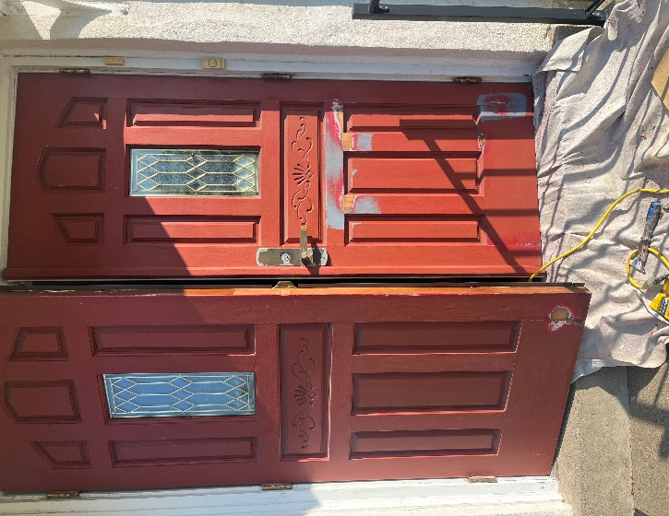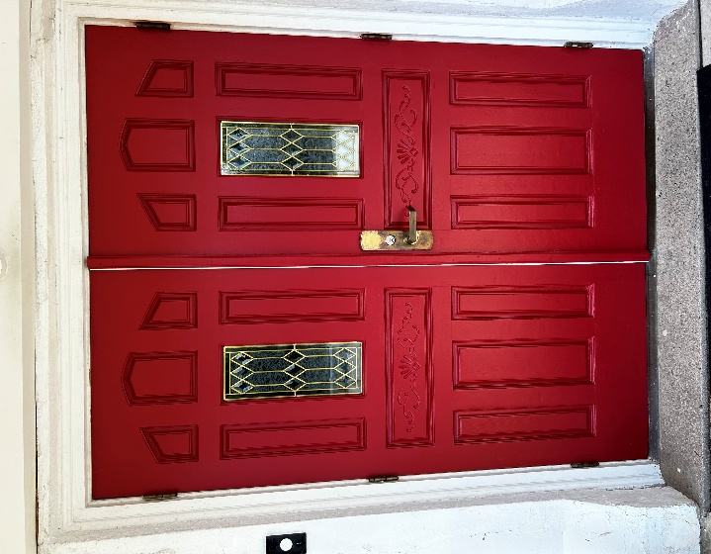
Before After

Steeple Lighting Repair

Steeple Lighting – 2 of our steeple lights are out, sadly the metal poles are bent due to high winds.
It was suggested that we could install the lights inside the steeple, to light up the tower.
We have met with the electrician, and this will be completed in the fall.

Fellowship Hall Windows Replacement

Project in 2026: We are looking to have our 11 large windows - fellowship hall, Handicapped bathroom, kitchen and Sunday School room replaced in 2026. The windows do not open or if they do, they fall down and they are allowing a lot of heat to escape in the winter months.
If you would like to make a donation to the aluminum replacement windows, same style as the ones we just installed in the steeple, please note on offering envelope and/or check - Fellowship Windows.
By mail: Chestnut Hill Church – 6870 Chestnut Hill Church Road, Coopersburg PA 18036, or depositing it in the collection plate at church.
Thank you for your kind and generous consideration !

Memorial Garden

Garden Clean-up will be Friday November 28th from 9 am till 11/12 noon.
We will need to cut down the flowers, pull some weeds and rake the mulch.
Thank you to Karen Billger, Ken Debus and Debbie Koder for weeding the garden and front flower beds through the summer.
Thank you to our Mowers! Harry Rupp, Jeff Bogert and Brett Koder.
Their weekly and by-weekly mowing around the church, cemetery and corner lot, help us to keep our expenses down.

Chestnut Hill Grief Support Group

Chestnut Hill Grief Support Group, led by Craig Adams, meets the last Saturday of the month, 1pm, in Followship Hall. We are now having Grief Chair Yoga at 12 pm before the support meeting starts, led by Cindy Buchter.
The Next meeting is September 27th at 1:00 pm, chair yoga at 12:00 pm.
Our fellowship is surrounded by TOTAL anonymity. Safe place!
I encourage you to reach out to see if the Group would be a good fit for you. Please call, text or email Craig Adams 610-554-4967, dcraig.adams8@gmail.com for a confidential, private conversation.

Financial Report

Checking / Savings Accounts:
(as of 08/31/2025)
QNB General Savings $ 44,587.61
Improvement Fund $ 9,132.72
Special Savings
Memorial Fund-
Mission $ 8,671.88
Garden/Landscaping $ 307.43
Steeple $ 6,822.23
WWW $ 1,371.11
New Church Sign $ 504.04
TBD (To Be Determined) $ 5,000.00
Special Savings Other $ 798.80
Total Special Savings $ 23,475.49
Investment Portfolio:
Miller Endowment $ 461,246.61
Hoff Endowment $ 192,534.95
Cemetery Portfolio:
QNB Checking $ 42,215.45
Ameriprise $ 78,840.24
Total Cemetery $ 121,055.69

Miller Endowment, investment held by Magellan Financial Inc, these funds are designated for income and all expenditures must be approved by Council and the Congregation. The initial investment was $415,000; the end of year investment (with accumulated earnings and market swings... gains and losses), ending balance is $461,246.61. Funds of $17,000 withdrawn July 2025. These funds currently reside in the Gen Fund but will appear in the Improvement Fund beginning Sept 2025

Vivian Hoff Endowment, investment held by Magellan Financial Inc., these funds are restricted and the interest earned has been designated for Music, Worship, Christian Education, and Community Outreach. All requests for funding are reviewed by the Hoff Endowment Board of Trustees and Council prior to disbursement. The initial investment was $150,000; the end of year investment value (with accumulated earnings and marketing swings... gains and losses), ending balance is $187,837.52.
Sponsored Jan 2025-June 2025: Coopersburg Fire Co $1,000; The Caring Place $750; Camelot for Children $750; and Veteran's Brotherhood $1,000


Church Contact Information:

Pastor Linda Rapp: (Pastor@chcucc.org)
Pastor Linda Rapp Phone: 610-462-7067
Secretary: Gloria Roeder (secretary@chcucc.org)
Treasurer: Karen Billger (treasurer@chcucc.org)
Sexton: Sandy Eckhart (sanddune13@yahoo.com)
Ministers: Every Member of the Congregation
Church Website: www.chestnuthillchurch.org
Church Phone Number: 610-967-1196

