November/December 2025 Volume 6
Chestnut Hill Church UCC
Newsletter

Hello Everyone! We have a busy Holiday Season coming up!!!
Garden Clean-up will be Friday November 28th from 9 am till 11/12 noon. See info under Church Updates.

Saturday, December 13, 2025 (10:00 am start) for CHC annual Wreaths Across America. See info under Special Events.

Christmas Eve Services Thursday, December 24th 4:30 PM

TABLE OF CONTENTS
A Letter from Pastor Linda …………………….……………...……pg. 2
Volunteer Opportunities………………………………………......…pg. 3
Outside the Church ………………………………….........................pg. 4-5
Women Working Wonders! ….………………………………….….pg. 4
Special Events……...……………………………………………...…pg. 6
Church Updates …………....……………………………………...... pg. 6-10 Chestnut Hill Grief Support Group ………………………….….…... pg. 11-13

Letter from Pastor Linda
Sisters and Brothers,
As many of you may know, I tendered my resignation with Chestnut Hill Church effective December 31, 2025. Please know that I did not come to this conclusion easily. I have been blessed to walk with you, talk with you, work beside you and guide you for the past three years. And I truly believe this was a gift from God for both me and the congregation.
And so, you may ask why and why now? In case you haven’t heard, this is my 3rd retirement. It’s time to really retire. In addition, my husband Bob will be retiring from his position at Bethlehem Emergency Sheltering effective December 15 as he has accepted a full-time call as the Pastor of Christ United Church of Christ in Bethlehem. It’s time for me to become the Pastor’s wife and be an active member of his congregation. I do plan to stay in touch. I’m certain you will find me at the pulpit now and then. I would also like to remain available for funerals, weddings, etc., if and the occasion arises.
And so, as I write this last newsletter, I wonder what words I can possibly leave with you for encouragement as you enter another time of uncertainty. They say, “it takes a village.” I believe that as a congregation you can weather this period of change because you’ve done it before. And you did well!
And so, I leave you with these words as reminders and encouragement. From the 17th chapter of John’s gospel, we find Jesus’ prayer for his disciples: “I in them and you in me, that they may become perfectly one, so that the world may know that you sent me and loved them even as you loved me.”
Also, from the 2nd chapter of Paul’s letter to the Philippians: make my joy complete: be of the same mind, having the same love, being in full accord and of one mind. Do nothing from selfish ambition or empty conceit, but in humility regard others as better than yourselves.
May God’s love surround you as seek new leadership and find your path forward. Be blessed and always be a blessing to others!
In His love,
Pastor Linda
Volunteer Opportunities

Finance Team

The Finance Team is looking for weekly Sunday Counters and people to join the finance team. The finance team reviews and sets the annual budget and then the budget is presented to Council in November for approval. If interested, please contact Debbie Koder 610-390-9026

Volunteer Opportunities

There are many opportunities within the church to share your time and talents to help the church with its mission in this world. We are looking for folks to serve on the Board of Trustees (building and maintenance team). If you are interested in helping, please contact Trustee – Debbie Koder.

Communion Assistants

We are looking for volunteers to help set up, serve, and break down the monthly communion elements on the first Sunday of each month. If you have never done this, someone will gladly show you where everything is and how to set it up.
You only need to arrive at church around 9:15 am, it takes about ½ hour to set up.
If you are interested, please let Marj Trinkle know. A sign-up sheet is available on the Lower Narthex bulletin board with detailed instructions.

Refreshments & Altar Flowers

Anyone who is interested in providing Refreshments or the Altar Flowers for any Sunday, there is a sign-up sheet on the bulletin board on the Lower Narthex. When services are being held in the Fellowship Hall during the summer months, sign-up sheets are on back tables.
Refreshments are served after the Worship Service in the Fellowship Hall downstairs. Coffee, tea and water are provided.
The Altar Flowers, you provide for the Sunday Worship Service and take them home with you. Please indicate if they are in dedication for someone.

Outside the Church

Women Working Wonders!
WWW Meetings is held on the 3rd Thursday of the month at 1 pm, at the church, either in the Sunday School Room or the Fellowship Hall. Everyone is welcome to join us with ideas or help.
Fundraiser totals:
Copperhead Grille on October 23rd raised $88.91 for church Utility bills.
Basket Social held October 3rd raised over $8,000 for our outreach program donating back to community. Food and Baked goods raised over $600 that will go to our utility bill.

Betty Lou’s Pantry
People have lost their SNAP cards (formerly known as food stamps), and with the government leveling tariffs and cutting funds to Second Harvest, etc., more and more people are struggling to get the food/essentials they need. Any and all donations are more than welcome and we will take everything the congregation can donate to help to BLP. Any and all donations are more than welcome. Thank you to such a generous congregation. We are little but we are mighty!
Betty Lou’s Pantry is always appreciative of any donations.
BLP is in need of meat helper, tuna helper, non-grape jelly/jam, and always, always toilet paper.
Most people buy what they think food pantry users want. The list below can help with donation needs. These are not always readily available at the food banks.
There is always a need for milk, butter, eggs and bread items but usually aren’t asked for because of spoilage. Some grocery stores supply these items when they have them on the morning of the food bank.
- Boxed milk since they don’t always have refrigerated milk to give.
- Some people don’t have can openers. So can openers or pop top canned goods.
- Vegetable oil, Sugar and flour, also cake mixes and icing. Some people put together cake mix, icing and candles in a foil baking pan. All in one to bake to celebrate a child’s birthday.
- Tea bags and coffee
- Spices and salt and pepper
- Fresh produce
- Seeds in Spring and Summer for those who grow plants and vegetables.
- Crackers, stove top stuffing
- Dish soap/Dishwashing detergent
- Feminine hygiene products are always greatly appreciated. Also, adult incontinence products ae greatly appreciated.
- Cat and Dog food for those who have animals and don’t want to part with them.
There is a cart in the Lower Narthex to place your donations and they will be delivered to BLP weekly. Thank you so much for your thoughtful tax deductible donations to those less fortunate than ourselves.

WWW FUNDRAISER!! - BURGERS FOR A CAUSE @ APPLEBEE’S
The WWW organization within Chestnut Hill Church has partnered with Applebee’s on a fundraiser which began earlier this year. So far, we purchased 300 burger certificates and sold 200 for a profit of $1,300 to go towards the expenses of our Church.
Burger certificates sell for $10 each. They are valid in MANY locations in PA and neighboring states and NEVER expire. Each certificate is good for any burger on their handcrafted burger menu (these burgers normally cost between $13 and $17). French Fries are included with your purchase.
Burger certificates make great stocking stuffers, or gifts for your hair stylist, nail tech, dental assistant, postal worker, neighbors, teenagers, etc!!
Certificates can be purchased from any WWW member on Sunday before or after worship service OR by emailing Karen (Treasurer) at treasurer@chcucc.org or by calling 484 358-1957.

Gift Cards
We will be offering our annual Gift Card Fundraiser program again this year!
Last year we sold over $29,325.00 in gift cards and earned our church $1,615.04 to be used towards our fuel bill!
Our gift cards are secure and you don’ t have to run around from store to store to purchase. You only pay the dollar value of the card!
Checks are made payable to Chestnut Hill Church and orders are due Sunday Nov. 30. Cards will be available to you on Sunday Dec. 14. There are copies of the fundraiser at the church. A copy was emailed to everyone. If you need another one emailed, email secretary@chcucc.org .
Please contact Debbie Koder 610-390-9026 for any questions.
Special Events

WREATHS ACROSS AMERICA

SAVE THE DATE of Saturday, December 13, 2025 (10:00 am start) for CHC annual Wreaths Across America. Again, this year, the Hoff Endowment has sponsored our wreaths! Thank you to Cindy Buchter for working with the Hoff family to make this happen for our Church! As in the past, we would love to see more family members of US Veterans at our event to lay a wreath on their loved one's headstone/grave. If you have or know of someone who has a family member and would like to attend, please ask them to contact either Karen Billger or Jeff Bogert (email and/or phone numbers listed below). A list of US Veteran laid to rest in the CHC Cemetery is also available upon request. CHC Cemetery has over 170 US Veterans laid to rest.
ANYONE is welcome to attend this event, so please spread the word. Last year we had a beautiful sunny day.
Please contact either Karen Billger (treasurer@chcucc.org) or Jeff Bogert (610 349-4042), or in person if you or you know someone who’d like to attend the event.

Iron Pigs Tickets
Calling all Iron Pigs fans! Our Faith night will be Friday June 5, 2026 at 5:00 pm.
Tickets will be $13.00 pp / with a $2.00 credit for food or souvenirs.
If interested, please contact Debbie Koder 610-390-9026

Church Updates

Memorial Garden

Garden Clean-up will be Friday November 28th from 9 am till 11/12 noon.
We will need to cut down the flowers, pull some weeds and rake the mulch.
Thank you to Karen Billger, Ken Debus and Debbie Koder for weeding the garden and front flower beds through the summer.
Special Thank you to Ken Debus taking care of the front flower beds.
Thank you to our Mowers! Harry Rupp, Jeff Bogert and Brett Koder.
Their weekly and by-weekly mowing around the church, cemetery and corner lot, help us to keep our expenses down.
Bell Tower Stairs

8 of the stair treads to the Bell tower have been replaced.
The tread boards were routed around the edges! The old treads were cracked or broken. No cost to the church!
The risers are old and sections were broken, to save from replacing the entire stairway, bracing was attached.
Thanks to Brett And Debbie Koder for doing this repair at no cost to the church

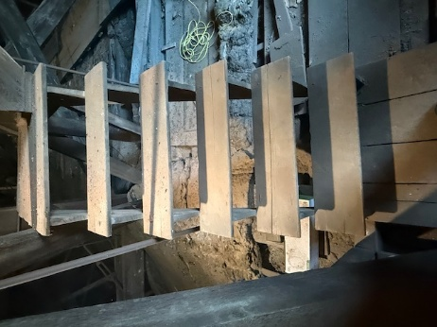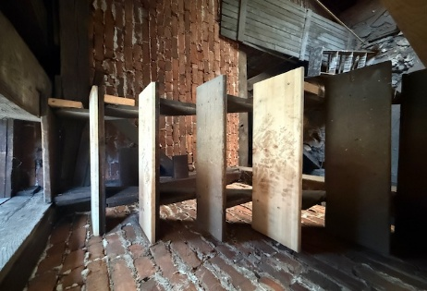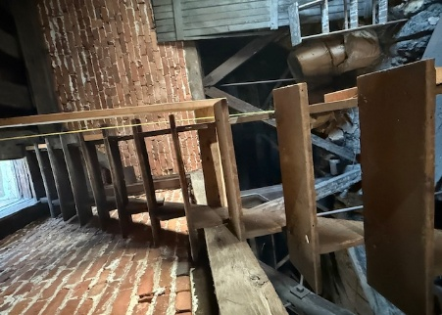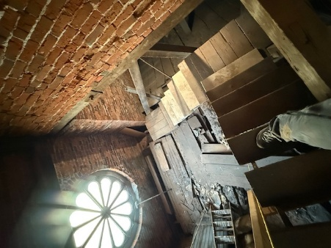
Before After Before After

Bell Tower Frame

As mentioned previously, the frame that holds our bell had a crack in it. We could hire out a company to make this repair $5000.00 or we could do it ourselves per their instructions.
Thank you Mike Gane for getting the metal, cutting the plates and installing, all at no cost to CHC!!!
First Picture is showing the crack in the frame and the bracket that had to be removed The other 2 pictures are the plates that the frame has been sandwiched between and bolted together.
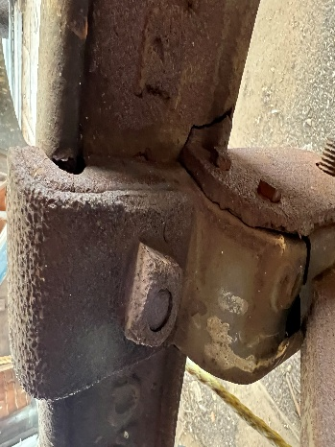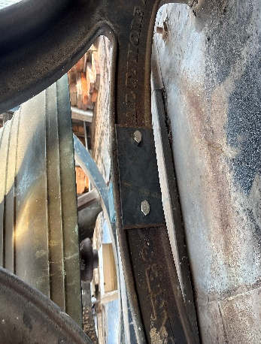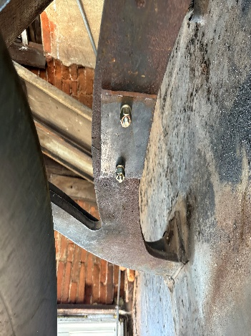
Crack in the frame, After Repair After Repair
bracket That was removed
Steeple Lighting Repair

Special thank you to Mike Gane and Brett Koder for removing the 2 dead/ non working outside steeple lights and cables. This will save us a little money, when the electrician comes to install the new lights inside the steeple!!!
New lights due to be installed this month!!
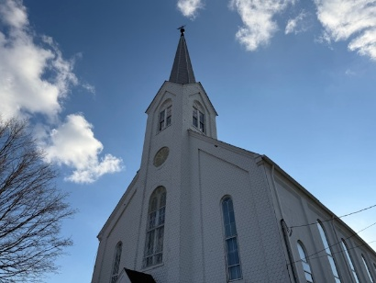

Fellowship Hall Windows Replacement

Project in 2026: We are looking to have our 11 large windows - fellowship hall, Handicapped bathroom, kitchen and Sunday School room replaced in 2026. The windows do not open or if they do, they fall down and they are allowing a lot of heat to escape in the winter months.
If you would like to make a donation to the aluminum replacement windows, same style as the ones we just installed in the steeple, please note on offering envelope and/or check - Fellowship Windows.
By mail: Chestnut Hill Church – 6870 Chestnut Hill Church Road, Coopersburg PA 18036, or depositing it in the collection plate at church.
Thank you for your kind and generous consideration!

Handicap Signs
Our handicapped signs were showing a little wear and tear, so they were given a face lift! Thank you to Debbie Koder for painting them.

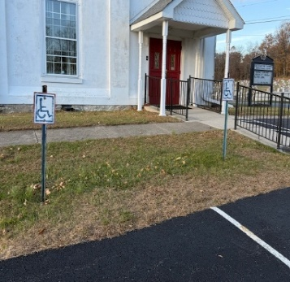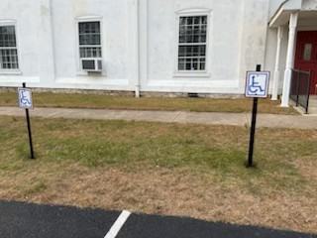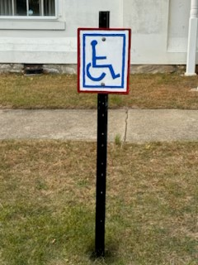
Before After Before After
Upstairs Storage Closet

Sometimes our closets become a place of clutter. Thank you to Brett Koder for building a new shelf in our upstairs hall closet.
Now there is better storage for the Altar flowers and other supplies.

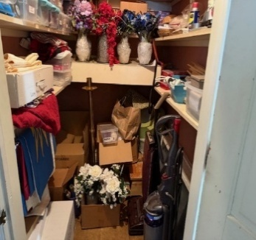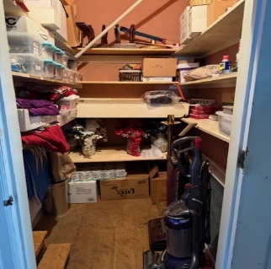
Before After

Back Door Repair

Last week Karen mentioned that there was a gap in the back door. Upon closer look, The door frame was actually separating from the door frame and the wall.
We thought we might need to hire a carpenter, but on Sunday Sam Leh was able to give us some guidance and suggestions. Thank you Sam!
Brett was able to compress the 2 walls with C Clamp to close the gap.
Door frame is back together and at no cost to the church.
Thank you Brett Koder for being able to do this repair!

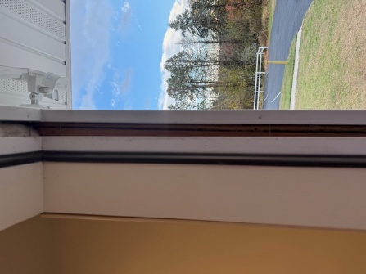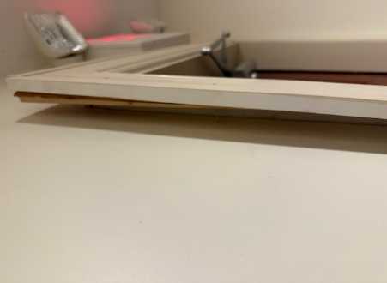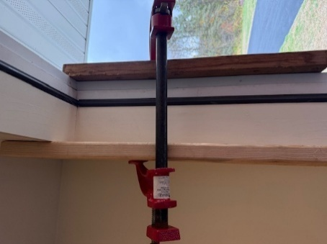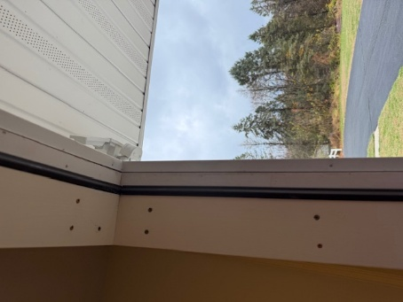
Before Before During After

Car Show and Trunk or Treat Event

Our Car Show and Trunk or Treat Event was a hit! We had 21 cars from old to newer ages! Plus, hot dogs, water and treats were handed out. Here are pictures of some of the cars and our snack area. They are looking forward to coming back in Spring for another car show at the Church!

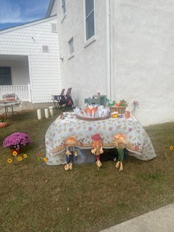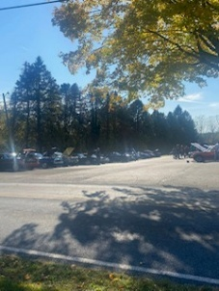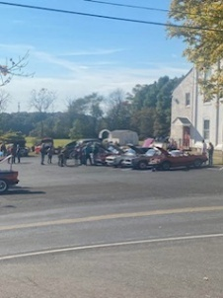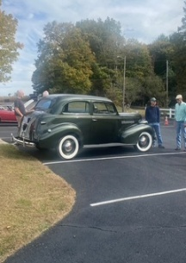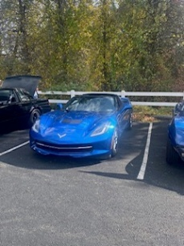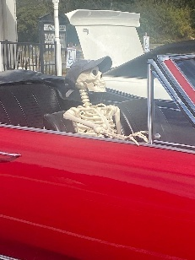

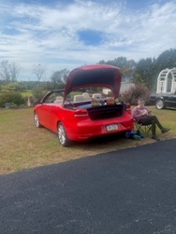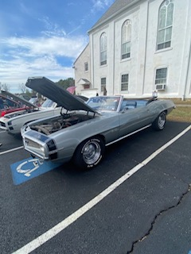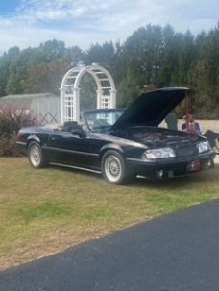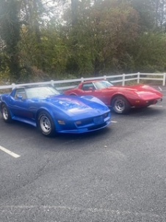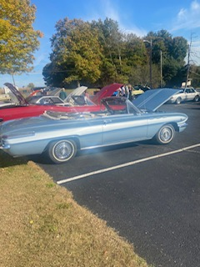

Leftover Candy from Trunk or Treat

Debbie Koder wanted to share a good share!
She saw on Facebook that there was a local woman collecting leftover candy from Halloween and it was being donated to the VFW in Sellersville and they were going to be sending the candy over to the troops. We had two buckets of candy left over from our trunk and treat and checked with several people as to whether or not we could donate this Candy to the VFW. Everyone was in agreement and she picked up the candy and met the woman at the Giant in Coopersburg.
Debbie had asked Megan to let me know how things went. This was her response :﻿
Hi 👋🏻 I am dropping off the candy this morning. I found out Helen does pay for the shipment out of her pocket. 5 boxes go to the troops and the rest is used to make stockings for local VA homes/hospitals ❤️ 70.3 lbs were collected in total!

Chestnut Hill Grief Support Group
GRIEF SUPPORT THE “WARMTH”
Seasonal Greetings, Chestnut Hill Church Family. I’m having a difficult time catching my breath with the speed of the calendar, faster every year, or so it seems. My partner, Arthritis, doesn’t enjoy the cold weather, perhaps you can relate. But despite the season, if you look close enough, there is warmth to it. Next year will mark the 8th Anniversary of our Grief Support Fellowship. I have been blessed, with the warmth and comfort of our members gathering each month, to find and deliver that comfort, to each other, as things and topics are shared in confidence. Always Christ centered. And, as you know our meeting begins with the comfort and warmth of Grief Yoga, God bless Cindy.
I’m very curious at times, why God has placed me in this group. The more time I spend in “HIS” word and Selah, God’s warmth is always there, directing the path. We shared in a Church service recently, that the memory of a song, hymn speaks residence to our minds, rather than last week’s sermon. Thank God for music. The 60’s group the “Byrds” prophetic lyrics, directly from Solomon’s Ecclesiastes , Chapter 3 verses 1-8, “To everything there is a season, a time for every purpose under heaven”, Please read the rest at your leisure and Selah. These inspired word from God, remind me of the “Grief Journey”.
The cold, sometimes painful memories of the loss of a loved one, or wherever you find yourself, on your grief journey: the memories can become triggers that really hurt. We practice turning these painful memories into “treasures”. The “Treasures” is where I find the “Warmth”.
Just like the seasons, Grief journeys are different and unique for all of us. We’ve learned on our Grief journey, “Death is not a terminus for Christians, It’s a Transition.” We all know and believe God sent his Son to us to heal and forgive. But Jesus, was God in Human form, experiencing Human emotions. The shortest verse in the Bible, John 11:35. “Jesus Wept”. I find the warmth and comfort in the scriptures, Revelation Chapter 21 verse 4. “And God will wipe away every tear from their eyes; there shall be no more death, nor sorrow, nor crying. There shall be no more pain, for the former things have passed away.”
God has placed another song in my mind and heart, reflecting the passing and the future passing of loved ones.
The song is “Scars in Heaven”, written by Mark Hall, and performed by the Christian band, Casting Crowns”. I encourage you to look it up on YouTube, Music. Please choose the lyrics playing, as the video version can be very painful to watch. Hang in there with the lyrics, there is a WARMTH in the message.

SCARS IN HEAVEN
“If I had only known the last time would be the last time
I would have put off all the things I had to do
I would have stayed a little longer
Held on a little tighter
Now what I’d give for one more day with you
‘Cause there’s a wound here in my heart where somethings missing
And they tell me that it’s going to heal with time
But I know you’re in a place
Where all your wounds have been erased
And knowing yours are healed is healing mine
The only scars in Heaven
They won’t belong to me and you
They’ll be no such thing as broken
And all the old will be made new
And the thought that makes me smile now
Even as the tears fall down
Is the only scars in heaven
Are the hands that hold you now

I know the road you walked was anything but easy
You picked up your share of scars along the way
Oh, but now you’re standing in the sun
You’ve fought your fight and your race is run
The pain is a million miles away

The only scars in heaven
They won’t belong to me and you
They’ll be no such thing as broken
And all the old will be made new
And the thought that makes me smile now
Even as tears fall down
Is that the only scars in heaven, yeah
Are the hands that hold you now

There’s not a day goes by that I don’t see you
You live on in all the better parts of me
Until I’m standing with you in the sun
I’ll fight this fight and this race I’ll run
Until I finally see what you can see .

Thank you, Church Family, for blessing me with this opportunity to try and provide warmth, the connection and kinship in Grief Support. To God be the Glory!!!!
Your Brother in Christ
Craig
The Next meeting is November 29th at 1:00 pm, chair yoga at 12:00 pm.
Chestnut Hill Grief Support Group, led by Craig Adams, meets the last Saturday of the month, 1pm, in Followship Hall. We have Grief Chair Yoga at 12 pm before the support meeting starts, led by Cindy Buchter.
Our fellowship is surrounded by TOTAL anonymity. Safe place!
I encourage you to reach out to see if the Group would be a good fit for you. Please call, text or email Craig Adams 610-554-4967, dcraig.adams8@gmail.com for a confidential, private conversation.


Church Contact Information:

Pastor Linda Rapp: (Pastor@chcucc.org)
Pastor Linda Rapp Phone: 610-462-7067
Secretary: Gloria Roeder (secretary@chcucc.org)
Treasurer: Karen Billger (treasurer@chcucc.org)
Sexton: Sandy Eckhart (sanddune13@yahoo.com)
Ministers: Every Member of the Congregation
Church Website: www.chestnuthillchurch.org
Church Phone Number: 610-967-1196

